**Day 3 Assignment(14/01/2021):**

**Assignment 2**

Take n number records through keyboards as Id,Name,Salary,Desg

(array id,name,salary,Desg).

Salary = salary + hra + da – pf;

Hra is 10% salary

Da is 7 % salary

Pf 5 % salary

If desg is manager desg.equals(“Developer”)

15% bonus

If developer 10% bonus

Else

5 % bonus

Id, name, salary( grossSalary +bonus ) and desg.

**Solution:**

import java.util.Scanner;

class Assignment2

{

public static void main(String args[])

{

Scanner sc=new Scanner(System.in);

System.out.println("Enter number of details you want to store:");

int n=sc.nextInt();

int []id= new int[n];

String []name=new String[n];

float []salary=new float[n];

String []desg=new String[n];

for(int i=0;i<n;i++)

{

System.out.println("Enter id of employee "+(i+1));

id[i]=sc.nextInt();

sc.nextLine();

System.out.println("Enter name of employee "+(i+1));

name[i]=sc.nextLine();

System.out.println("Enter salary of employee "+(i+1));

salary[i]=sc.nextFloat();

sc.nextLine();

System.out.println("Enter designation of employee "+(i+1));

desg[i]=sc.nextLine();

System.out.println("\n");

}

for(int k=0;k<n;k++)

{

float hra,da,pf;

hra=salary[k]*0.1f;

da=salary[k]*0.07f;

pf=salary[k]*0.05f;

if(desg[k].equals("manager"))

{

salary[k]=(salary[k]+hra+da-pf)+(salary[k]*0.15f);

System.out.println("\n");

System.out.println("Details of Employee:"+(k+1));

System.out.println("id="+id[k]);

System.out.println("Name="+name[k]);

System.out.println("Salary="+salary[k]);

System.out.println("Designation="+desg[k]);

}

else if(desg[k].equals("developer"))

{

salary[k]=(salary[k]+hra+da-pf)+(salary[k]*0.1f);

System.out.println("\n");

System.out.println("Details of Employee:"+(k+1));

System.out.println("id="+id[k]);

System.out.println("Name="+name[k]);

System.out.println("Salary="+salary[k]);

System.out.println("Designation="+desg[k]);

}

else

{

salary[k]=(salary[k]+hra+da-pf)+(salary[k]*0.05f);

System.out.println("\n");

System.out.println("Details of Employee:"+(k+1));

System.out.println("id="+id[k]);

System.out.println("Name="+name[k]);

System.out.println("Salary="+salary[k]);

System.out.println("Designation="+desg[k]);

}

}

}

}

Output:

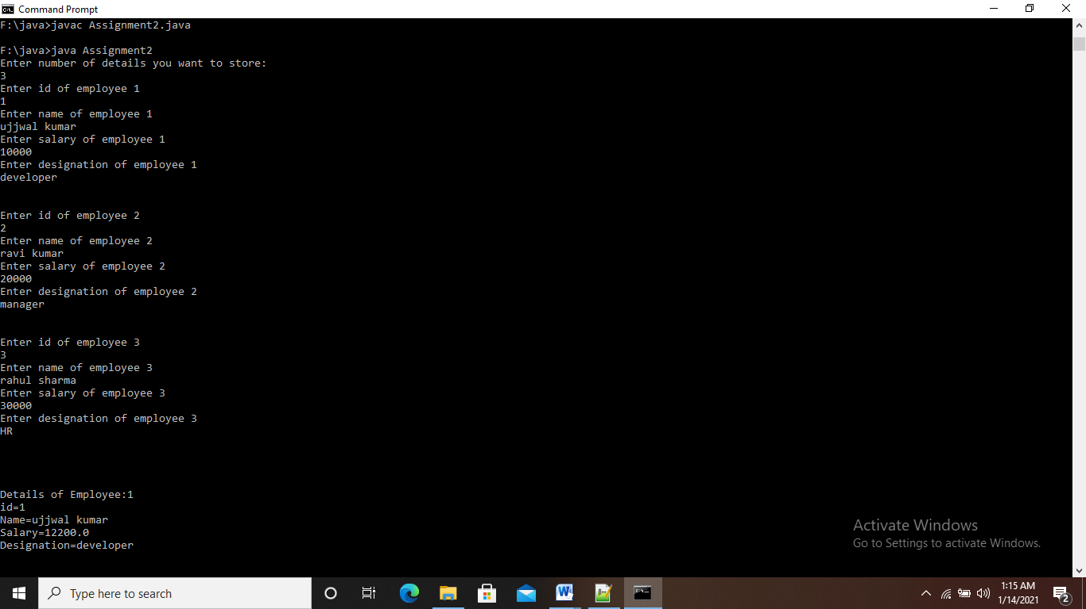

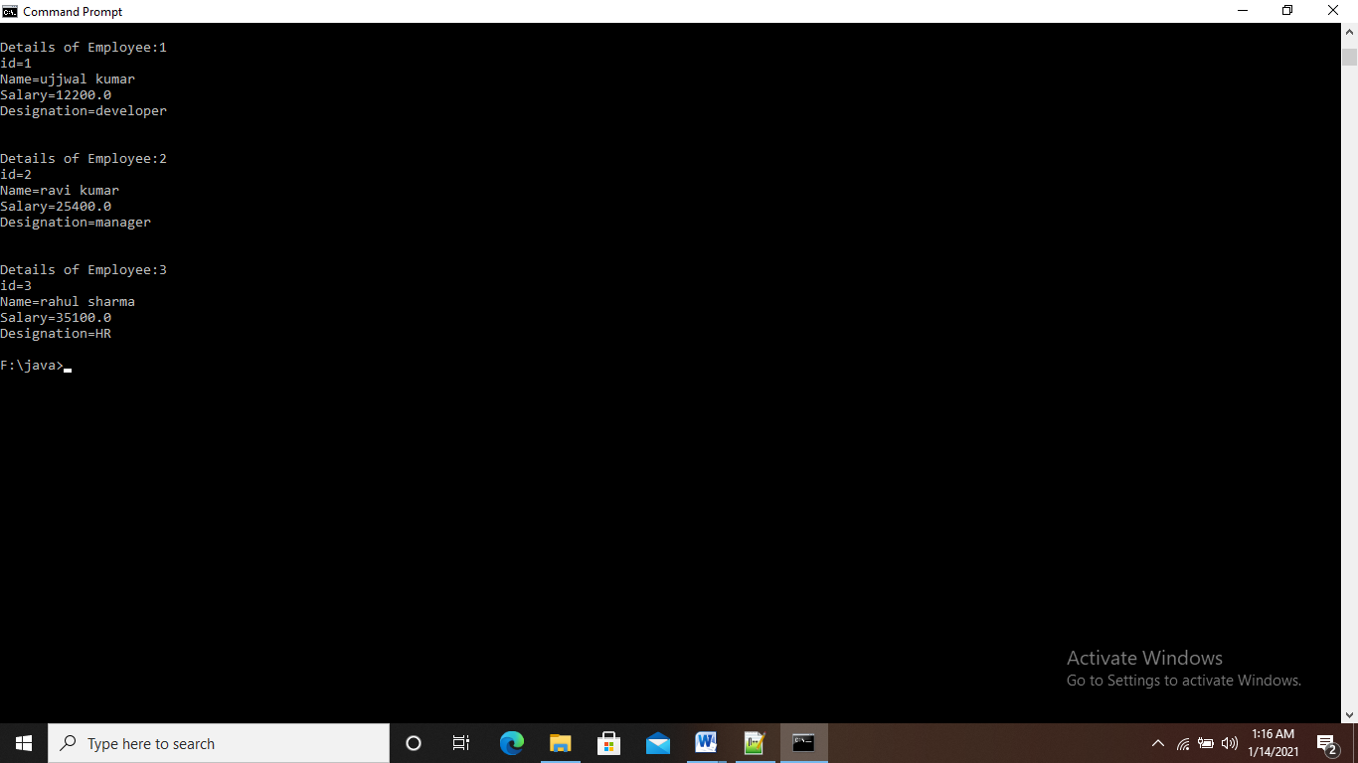

**Assignment 3**

Create EmployeeDetails class with 4 instance array variables.

EmployeeDetails() : memory size for array id,name,salary, desg must assign in constructor at run time.

read()

read all employee id,name,salary,desg

calSalary()

hra, da, pf local variables.

calculate salary

bonus()

apply bonus

display()

display details

EmployeeTest :

Main methods

Object creation

And calling all methods

Take n number records through keyboards as Id,Name,Salary,Desg

(array id,name,salary,Desg).

Salary = salary + hra + da – pf;

Hra is 10% salary

Da is 7 % salary

Pf 5 % salary

If desg is manager

15% bonus

If developer 10% bonus

Else

5 % bonus

Id, name, salary( grossSalary +bonus ) and desg

**Solution:**

import java.util.Scanner;

class EmployeeDetails

{

Scanner sc=new Scanner(System.in);

int n;

EmployeeDetails(int size)

{

n=size;

id=new int [size];

name=new String [size];

salary=new float [size];

salarycpy=new float[size];

desg=new String [size];

}

int []id;

String []name;

float []salary;

float []salarycpy;

String []desg;

//......................................................................

void read()

{

for(int i=0;i<n;i++)

{

System.out.println("Enter id of employee "+(i+1));

id[i]=sc.nextInt();

sc.nextLine();

System.out.println("Enter name of employee "+(i+1));

name[i]=sc.nextLine();

System.out.println("Enter salary of employee "+(i+1));

salary[i]=sc.nextFloat();

salarycpy[i]=salary[i];

sc.nextLine();

System.out.println("Enter designation of employee "+(i+1));

desg[i]=sc.nextLine();

System.out.println("\n");

}

}

//....................................................................

void calsalary()

{

for(int k=0;k<n;k++)

{

float hra,da,pf;

hra=salary[k]*0.1f;

da=salary[k]*0.07f;

pf=salary[k]*0.05f;

salary[k]=salary[k]+hra+da-pf;

}

}

//.....................................................................

void bonus()

{

for(int k=0;k<n;k++)

{

salary[k]=salarycpy[k];

float hra,da,pf;

hra=salary[k]*0.1f;

da=salary[k]*0.07f;

pf=salary[k]*0.05f;

if(desg[k].equals("manager"))

{

salary[k]=(salary[k]+hra+da-pf)+(salary[k]*0.15f);

}

else if(desg[k].equals("developer"))

{

salary[k]=(salary[k]+hra+da-pf)+(salary[k]*0.1f);

}

else

{

salary[k]=(salary[k]+hra+da-pf)+(salary[k]*0.05f);

}

}

}

//.......................................................................

void display()

{

for(int k=0;k<n;k++)

{

System.out.println("Details of Employee:"+(k+1));

System.out.println("id="+id[k]);

System.out.println("Name="+name[k]);

System.out.println("Salary="+salary[k]);

System.out.println("Designation="+desg[k]);

System.out.println("\n");

}

}

}

//........................................................................

class EmployeeTest

{

public static void main(String args[])

{

Scanner sc=new Scanner(System.in);

System.out.println("Enter Number of records you want to store:");

int x=sc.nextInt();

EmployeeDetails empd=new EmployeeDetails(x);

empd.read();

empd.calsalary();

empd.bonus();

empd.display();

}

}

Output:

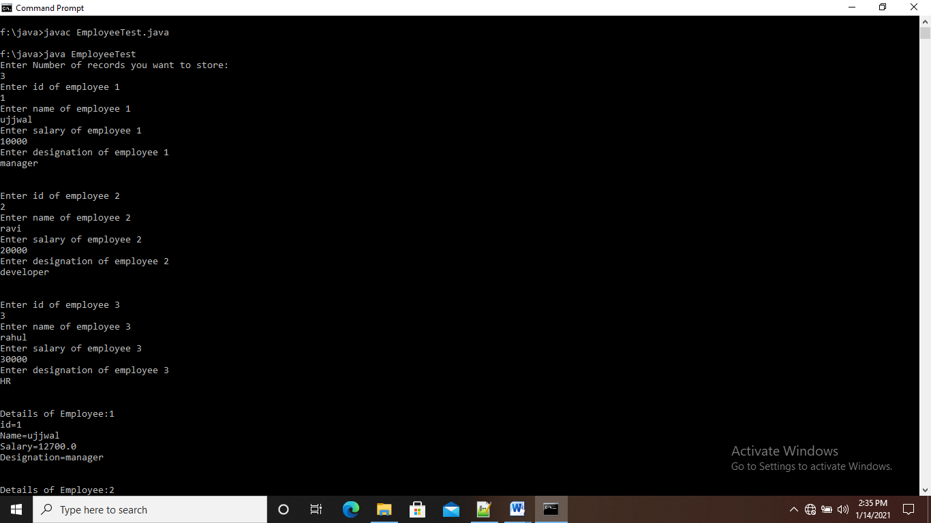

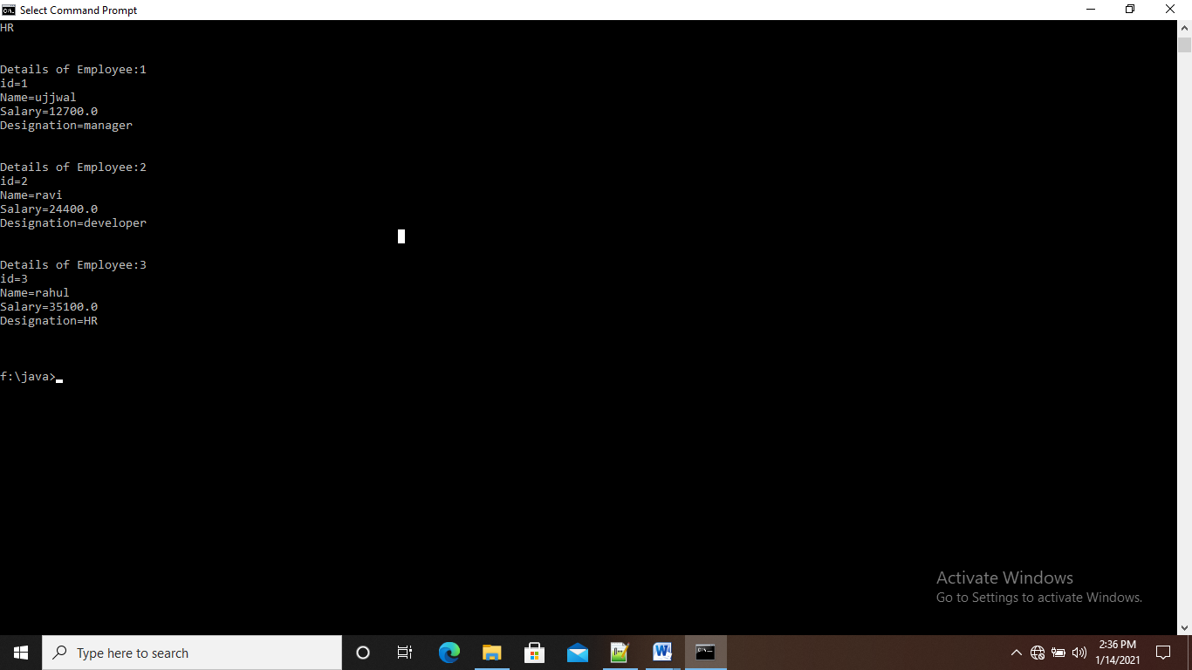

**Assignment 1**

do{

Online Examination

1:English , 2 : Math 3 : GK

switch() {

case 1

3 Q

case 2

3 Q

case 3

3 Q

}

Do want to continue ?

}while();

Result g_total > 70

Result + 10

Result>=90 selected else try next time.

**Solution:**

import java.util.Scanner;

public class OnlineExam

{

public static void main(String args[])

{

System.out.println("Online Examination System");

Scanner sc=new Scanner(System.in);

int choice;

int c=0,d=0,e=0,n=3,marks1=0,marks2=0,marks3=0;

do{

System.out.println("Press 1 for English \nPress 2 for Maths \nPress 3 for GK ");

choice=sc.nextInt();

switch(choice)

{

case 1:if(c==0)

{

System.out.println("Welcome to English Examination");

System.out.println("1.Please,stop.....so many mistakes.");

System.out.println("1. to make\n2. make\n3. making\n4. makes");

int p1=sc.nextInt();

if(p1==3)

{

marks1=marks1+10;

}

else{

System.out.println("Wrong Answer.");

}

System.out.println("2.The English.....English");

System.out.println("1. speak\n2. spoke\n3. spoken\n4. is spoken");

int p2=sc.nextInt();

if(p2==1)

{

marks1=marks1+10;

}

else{

System.out.println("Wrong Answer.");

}

System.out.println("3.The rain comes.....the clouds.");

System.out.println("1. in\n2. near\n3. from\n4. under");

int p3=sc.nextInt();

if(p3==3)

{

marks1=marks1+10;

}

else{

System.out.println("Wrong Answer.");

}

System.out.println("This Section Completed successfully...");

c++;

n--;

break;

}

else{

System.out.println("You have already done this section");

break;

}

case 2:if(d==0)

{

System.out.println("Welcome to Maths Examination");

System.out.println("1.Can we write 0 in the form of p/q?");

System.out.println("1. Yes\n2. No\n3. Cannot be explained\n4. None of the above");

int q1=sc.nextInt();

if(q1==1)

{

marks2=marks2+10;

}

else{

System.out.println("Wrong Answer.");

}

System.out.println("2.Every rational number is:");

System.out.println("1. Whole number\n2. Natural number\n3. Integer\n4. Real number");

int q2=sc.nextInt();

if(q2==4)

{

marks2=marks2+10;

}

else{

System.out.println("Wrong Answer.");

}

System.out.println("3.If the coordinates of a point are(0,-4),then it lies in:");

System.out.println("1. X-axis\n2. Y-axis\n3. At origin\n4. Between x-axis and y-axis");

int q3=sc.nextInt();

if(q3==2)

{

marks2=marks2+10;

}

else{

System.out.println("Wrong Answer.");

}

System.out.println("This Section Completed successfully...");

d++;

n--;

break;

}

else{

System.out.println("You have already done this section");

break;

}

case 3:if(e==0)

{

System.out.println("Welcome to GK Examination");

System.out.println("1.Which is longest river in the world?");

System.out.println("1. Ganga\n2. Nile\n3. Amazon\n4. Niger");

int r1=sc.nextInt();

if(r1==2)

{

marks3=marks3+10;

}

else{

System.out.println("Wrong Answer.");

}

System.out.println("2.Which is the biggest continent in the world?");

System.out.println("1. North America\n2. Aisa\n3. Africa\n4. Australia");

int r2=sc.nextInt();

if(r2==2)

{

marks3=marks3+10;

}

else{

System.out.println("Wrong Answer.");

}

System.out.println("3.Which is india's first super computer?");

System.out.println("1. Param8000\n2. param80000\n3. param800\n4. param8");

int r3=sc.nextInt();

if(r3==1)

{

marks3=marks3+10;

}

else{

System.out.println("Wrong Answer.");

}

System.out.println("This Section Completed successfully...");

e++;

n--;

break;

}

else{

System.out.println("You have already done this section");

break;

}

default:System.out.println("invalied choice...");

}

if(n!=0)

{

System.out.println("Do you want to continue with another section?\nPress 1 for YES \nPress 2 for NO ");

int ch=sc.nextInt();

switch(ch)

{

case 1:System.out.println("YES");

break;

case 2:System.out.println("NO");

if(c==0 || d==0 || e==0)

{

System.out.println("You have not completed the Exam...Please Complete");

}

break;

default:System.out.println("invalied choice...");

}

}

else{

System.out.println("Exam Completed");

System.out.println("Thank You");

}

}while(n!=0);

int result=0;

System.out.println("Marks in english="+marks1);

System.out.println("Marks in maths="+marks2);

System.out.println("Marks in GK="+marks3);

int totalmarks=marks1+marks2+marks3;

System.out.println("Total Marks="+totalmarks);

if(totalmarks>=70)

{

result=totalmarks+10;

System.out.println("Final Marks="+result);

}

if(result>=90)

{

System.out.println("Congratulations. You are Selected");

}

else{

System.out.println("Sorry, not passed. Please try next time");

}

}

}

**Output:**

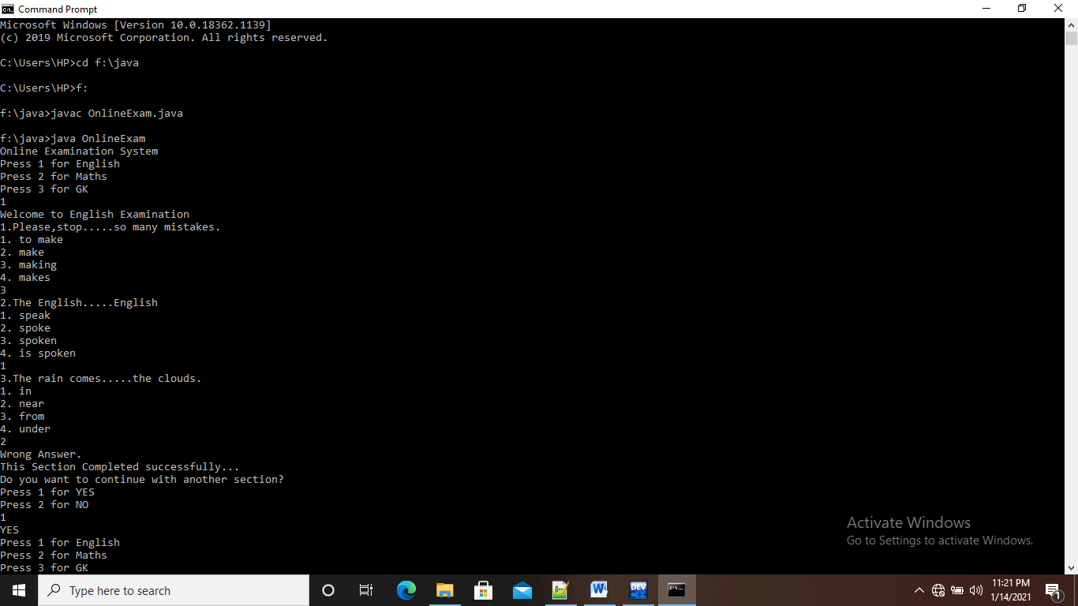

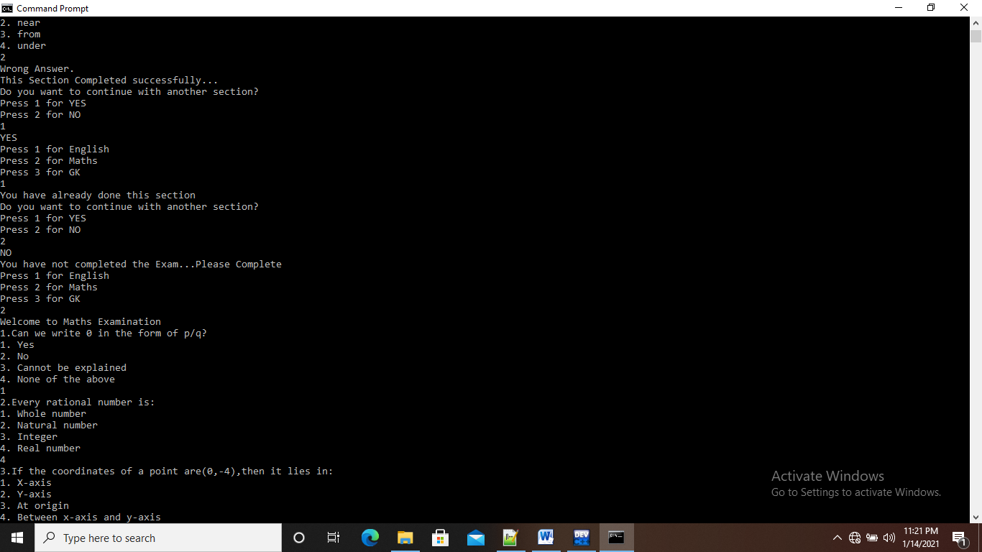

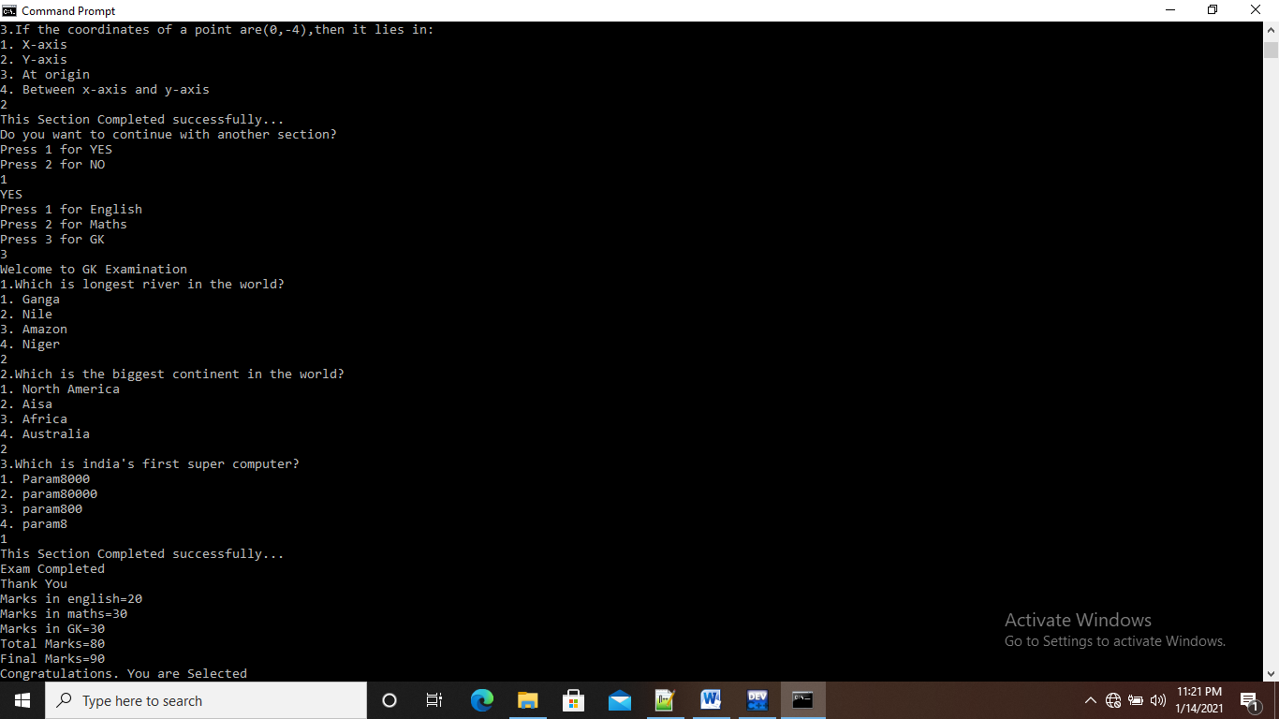

**Day 4 Assignment:**

**Assignment 4:**

Manager / Programmer is a Employee

Employee has a Address

class Employee { super class must be generic

id,name,salary

Scanner obj = new Scanner(System.in);

Address add = new Address();

methods

read() id,name,salary

, calSalary() : hra, da and pf

dislay()

}

class Manager extends Employee { sub must be specific

numberOfEmp : numbers

readMgr() numberOfEmp

add.readAdd();

disMgr();

numberOfEmp

add.disAdd();

}

class Programmer extends Employee{ sub must be specific

projectName: string

readPrg()

projectName

add.readAdd();

disPrg();

}

class Address {

city, state, pinCode

Scanner obj = new Scanner();

readAdd()

read city,state and pincode

disAdd();

city, state and pincode

}

EmployeeTest

Main Don’t create the Employee class object.

S.O.P(ManagerDetails);

Manager mgr

mgr.read() 3 details

mgr.readMgr() 1 own details, 3 address details

S.O.P(ProgramerDetails)

Programmer prg

prg.read()

prg.readPrg()

mgr.calSalary();

prg.calSalary()

Display Manager and Programmer details.

**Solution:**

import java.util.Scanner;

class Employee

{

int id;

String name;

float salary;

Scanner sc=new Scanner(System.in);

Address add=new Address();

void read()

{

System.out.println("Enter id:");

id=sc.nextInt();

sc.nextLine();

System.out.println("Enter Name:");

name=sc.nextLine();

System.out.println("Enter salary:");

salary=sc.nextFloat();

}

void calsalary()

{

float hra,da,pf;

hra=salary*0.1f;

da=salary*0.07f;

pf=salary*0.05f;

salary=salary+hra+da-pf;

}

void display()

{

System.out.println("\n");

System.out.println("Id="+id);

System.out.println("name="+name);

System.out.println("salary="+salary);

}

}

//..........................................................................

class Manager extends Employee

{

int number;

void readmgr()

{

System.out.println("Enter Number of Employee:");

number=sc.nextInt();

add.readadd();

}

void dismgr()

{

System.out.println("Number of Employee="+number);

add.disadd();

}

}

//.......................................................................

class Programmer extends Employee

{

String projectname;

void readprg()

{

sc.nextLine();

System.out.println("Enter name of project:");

projectname=sc.nextLine();

add.readadd();

}

void disprg()

{

System.out.println("Project="+projectname);

add.disadd();

}

}

//.......................................................................

class Address

{

String city,state;

int pincode;

Scanner obj=new Scanner(System.in);

void readadd()

{

System.out.println("Enter city:");

city=obj.nextLine();

System.out.println("Enter state:");

state=obj.nextLine();

System.out.println("Enter pincode:");

pincode=obj.nextInt();

}

void disadd()

{

System.out.println("city="+city);

System.out.println("state="+state);

System.out.println("pincode="+pincode);

}

}

//.......................................................................

class Employeetesting

{

public static void main(String args[])

{

System.out.println("Manager Details");

Manager mgr=new Manager();

mgr.read();

mgr.readmgr();

System.out.println("Programmer Details");

Programmer prg=new Programmer();

prg.read();

prg.readprg();

mgr.calsalary();

prg.calsalary();

mgr.display();

mgr.dismgr();

prg.display();

prg.disprg();

}

}

**Output:**

